**Machine Learning Assignment-02**

**Name:S.Venkatachalam Roll No:195214158**

**1.PROBLEM STATEMENT:**

Given about data about a building a machine model that can predict homeprices and square feet of area

House price=m*area+b

**1.OBJECTIVES:**

The aim is to **predict** the efficient **house** pricing for real estate customers with respect to their budgets and priorities. By analyzing previous market trends and price ranges, and also upcoming developments future prices will be **predicted…**

**2.METHODOLOGY**

There are several approaches that can be used to determine the price of the **house**, one of them is the **prediction** analysis. ... The time-series approach is to look for the relationship between current prices and prevailing prices. The second approach is to use linear regression based on hedonic pricing [6], [7.

**3.DATA SET_DESCRIPTION**.

The **dataset** consists of 80 columns of unique independent variables,1460 rows in the train data and 1459 rows in the test data. The goal of this competition is to **predict** the sales prices of **houses** based on these variables.

**4.PREPROCESSING.**

**House price prediction** can help the developer determine the selling **price** of a **house** and can help the customer to arrange the right time to purchase a **house**. There are three factors that influence the **price** of a **house** which include physical conditions, concept and location.

**5.BUILDING ML MODELS:**

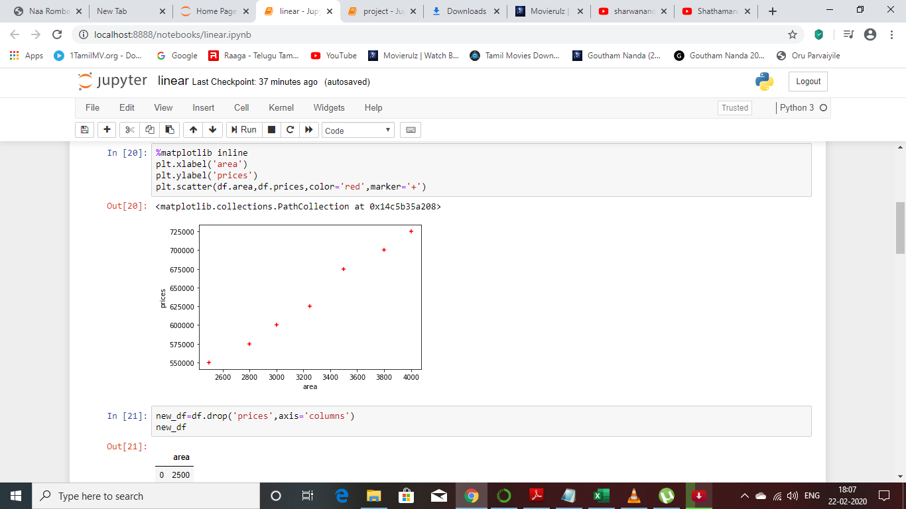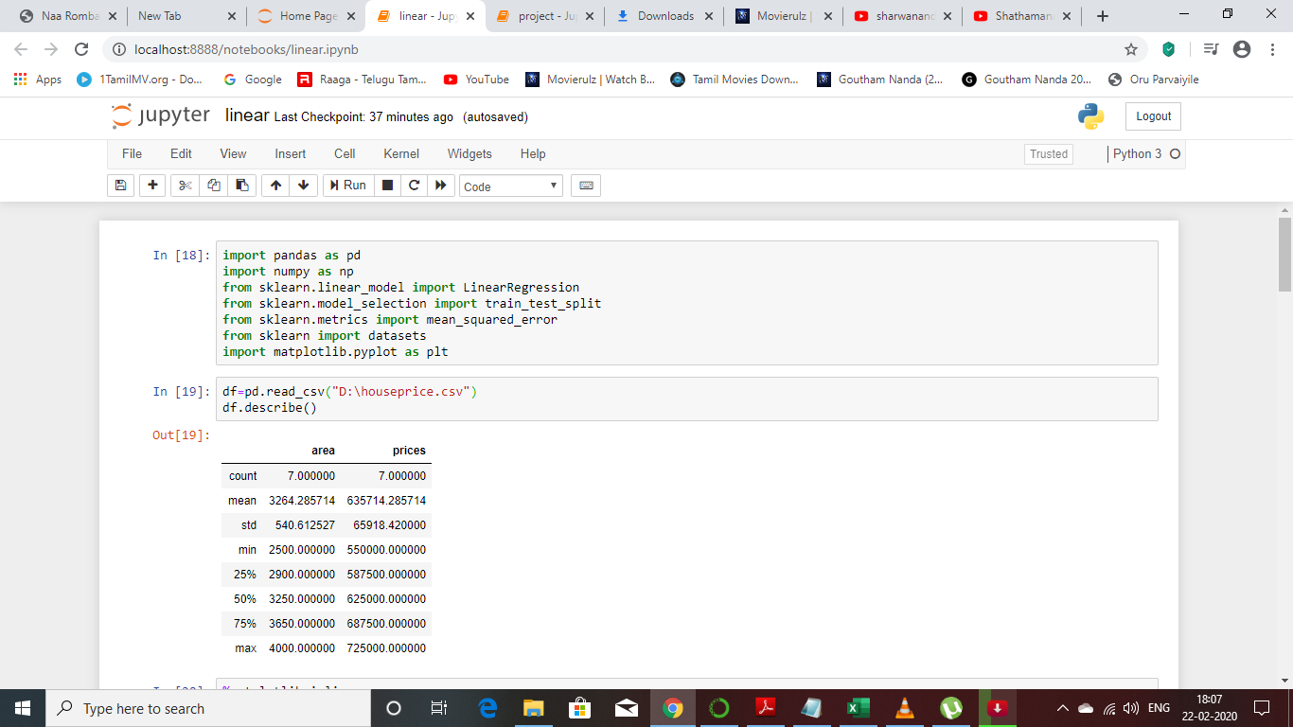

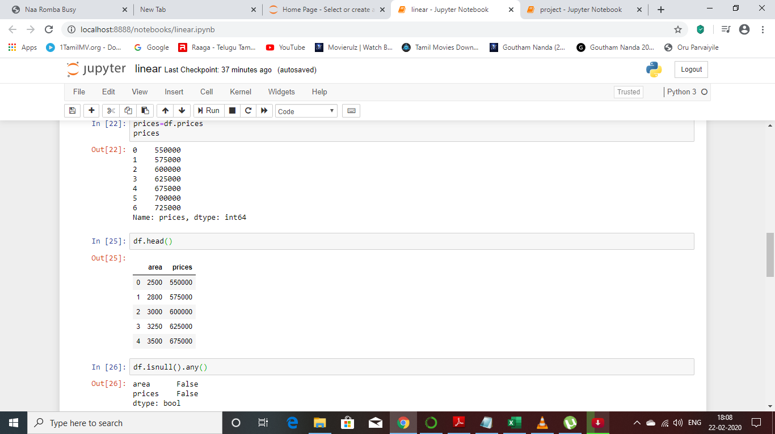

**6.TRAINING AND EVALUATION.**

In this final section of the project, you will construct a model and make a prediction on the client's feature set using an optimized model from  fitmodel.

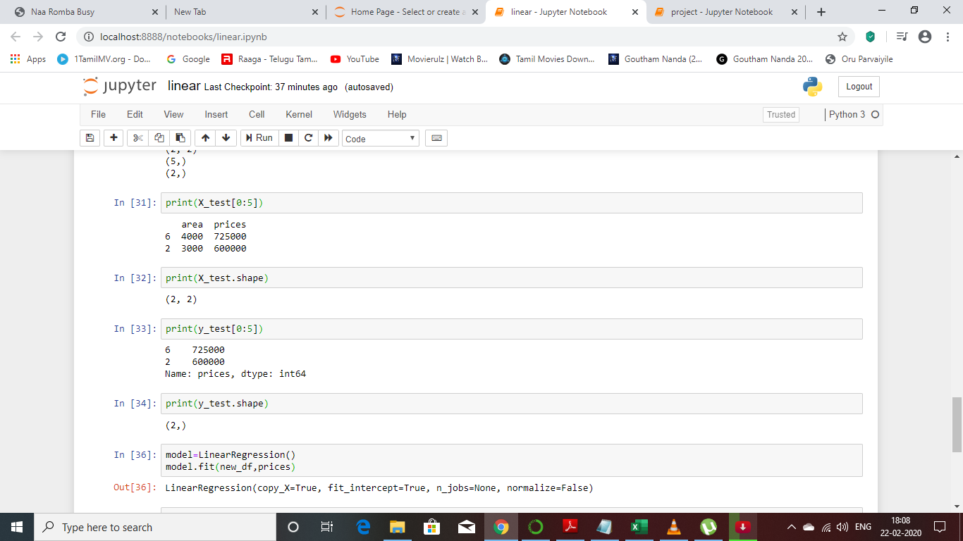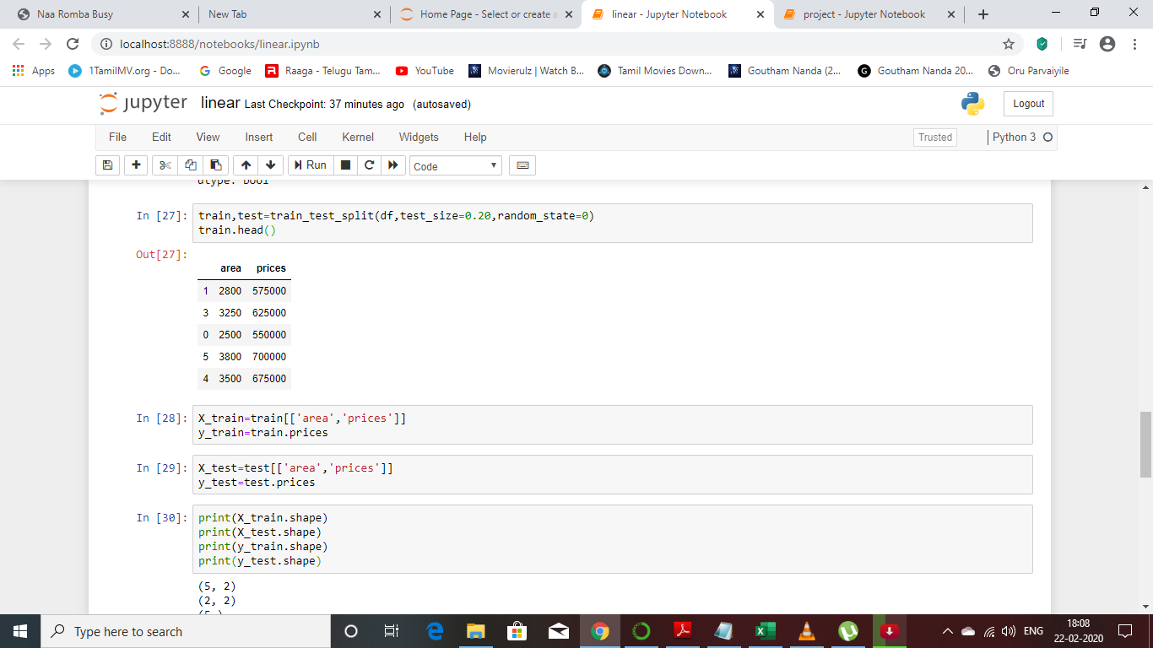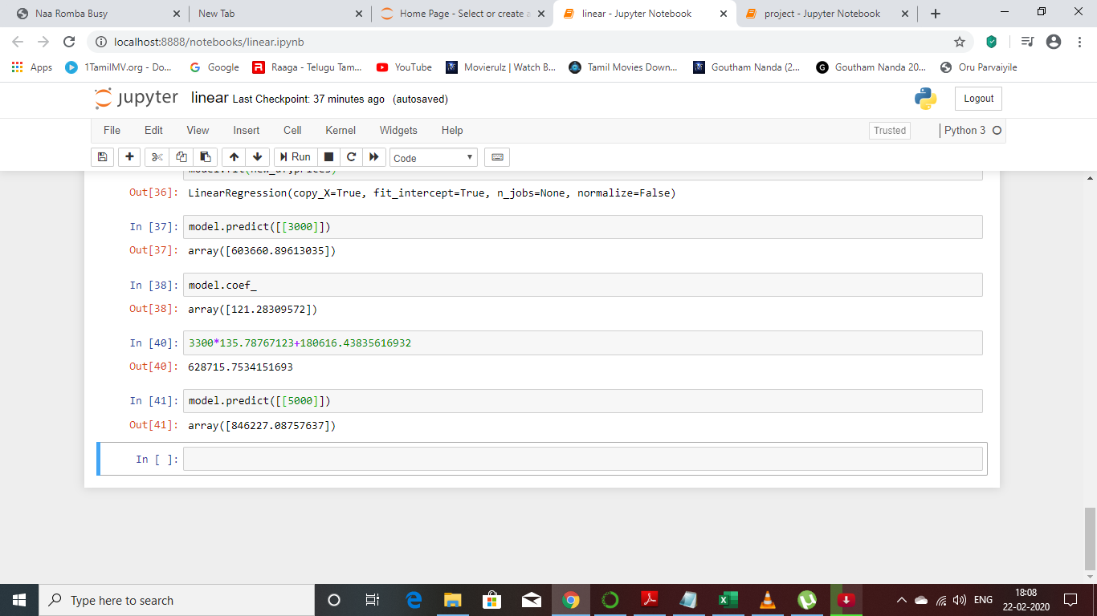

**7.CONCLUSION:**

**1.**it will calculate the area and do the scatter plot and linear regression model and will display the output